Faculty Guide for Evaluating Open Education Resources

*With so many freely available resources online, choosing OER can be overwhelming. This checklist contains some suggestions for faculty when choosing resources for use in the classroom.*

# RELEVANCE

Does the information directly address one or more of the class objectives?

# ACCURACY

Is the information accurate? Are there major content errors or omissions? Are there spelling errors or typos?

Has the material been peer reviewed?

# PRODUCTION QUALITY

Is the information clear and understandable? Is the layout and interface easy to navigate? Do the design features enhance learning?

For multimedia resources, are the audio/video quality high?

# ACCESSIBILITY

Is the resource available in alternative formats (e.g. .doc or .odf)? For audio or video resources, is there a transcript or subtitles?

# INTERACTIVITY

Does the resource encourage active learning and class participation? If not, are you able to add that to the resource?

Are there opportunities for students to test their understanding of the material (e.g. a video with embedded questions)?

# LICENSING

Does the license allow for educational reuse of the materials?

Does the license allow modifications or adaptations of the materials? If so, can you modify the resource to better fit the class objectives or encourage active learning?

# FURTHER INFORMATION

JISC. (n.d.). *Open Educational Resources infoKit* [wiki]. Retrieved from <http://bit.ly/oerinfokit>.

MERLOT. (n.d.). MERLOT Faculty Development Portal: EVALUATION CRITERIA. Retrieved from <http://facultydevelopment.merlot.org/ReviewCriteria.html>.

Shank, J. D. (2014). *Interactive open educational resources: A guide to finding, choosing, and using what's out there to transform college teaching.* San Francisco: Jossey-Bass.

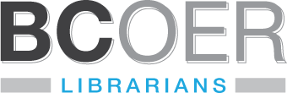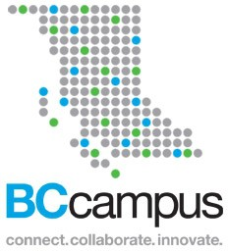Supported by

*This guide is a creation of the BCOER, a group of BC postsecondary librarians working together to support the use of quality Open Educational Resources (OER). For more information about BCOER and its activities, go to* ***open.bccampus.ca****.*



*This work is licensed under a Creative Commons Attribution*

*4.0 International License.*

Apr 2015, v2